
American International University-Bangladesh (AIUB)

Faculty of Science & Technology (FST)
Department of Computer Science

Introduction to Data Science
Final-Term Project Report
Spring 2025-2026

Section: F
Group:10

Project Contributions

SL # | Student Name & ID | Contributions
1 | Name: Afnan Bin Islam Nahin  ID: 22-49350-3 | Topic selection, dataset source selection, disease-specific keyword planning, methodology design, TF-IDF feature extraction, PCA dimensionality reduction, K-Means clustering, evaluation using Silhouette Score and Davies-Bouldin Index, cluster keyword interpretation, UMAP visualization, results analysis, and report writing.
2 | Name: Aman Ullah  ID: 22-49345-3 | Dataset cleaning, missing/blank abstract removal, duplicate record checking, abstract length filtering, balanced sample creation, disease group distribution checking, output collection, table preparation, graph preparation, formatting support, and final report review.
3
4

Disease-Specific Knowledge Mapping from Biomedical Abstracts Using TF-IDF, PCA, and K-Means Clustering

Methodology
The methodology of this study was designed to identify disease-related themes from biomedical research abstracts using unsupervised text clustering. The complete process included dataset preparation, disease-specific document selection, text preprocessing, TF-IDF feature extraction, dimensionality reduction, clustering, evaluation, and cluster interpretation. Since the aim of this work was to discover hidden thematic patterns, the disease labels were used only for dataset preparation and result interpretation, not for training the clustering model.
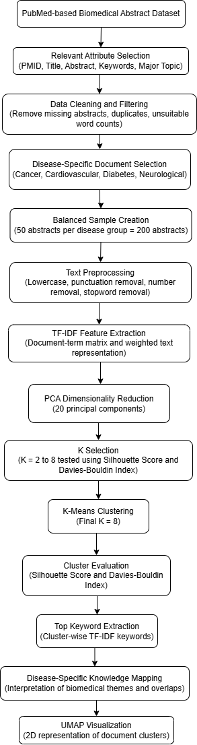
Fig. 1. Proposed methodology pipeline for disease-specific biomedical knowledge mapping.

A. Dataset Preparation
A PubMed-based biomedical research abstract dataset was used in this study. The dataset contained biomedical publication information such as PubMed ID, title, abstract, abstract word count, journal name, publication year, country, keywords, and major topic. Since this work focuses on text-based knowledge mapping, the abstract field was used as the main textual input.
At first, only the relevant attributes were selected from the original dataset. Records with missing or empty abstracts were removed because documents without abstracts could not contribute to text clustering. Duplicate entries were also removed using PubMed ID and title. To keep the document length consistent, only abstracts containing 80 to 350 words were kept. This range helped remove very short abstracts with insufficient information and very long abstracts that could add unnecessary noise.

Table I. Summary of the Prepared Dataset
Item | Description
Dataset Type | Biomedical research abstracts
Source Type | PubMed-based abstract dataset
Selected Text Field | Abstract
Selected Metadata | PMID, title, journal, year, country, keywords, major topic
Final Sample Size | 200 abstracts
Disease Categories | Cancer, Cardiovascular, Diabetes, Neurological
Documents per Category | 50
Abstract Length Range | 80–350 words

B. Disease-Specific Document Selection
Four disease-related categories were selected for this study: cancer, cardiovascular disorders, diabetes, and neurological disorders. These categories were chosen because they represent major areas of biomedical research and contain sufficient abstracts in the dataset.
Keyword-based filtering was used to select abstracts related to each disease category. To reduce overlap, documents containing keywords from more than one disease category were excluded during sampling. After filtering, 50 abstracts were randomly selected from each disease group, resulting in a balanced dataset of 200 abstracts.

Table II. Disease-Specific Keyword Patterns Used for Document Selection
Disease Group | Keyword Pattern
Diabetes | diabetes, insulin, glucose, glycemic
Cancer | cancer, tumor, tumour, oncology, carcinoma, chemotherapy
Cardiovascular | cardiovascular, heart disease, hypertension, myocardial, coronary
Neurological | neurological, brain, Alzheimer, Parkinson, dementia, stroke

C. Text Preprocessing
The selected abstracts were preprocessed before feature extraction. The text was converted into lowercase to maintain consistency. Punctuation marks, numeric values, stopwords, and extra spaces were removed. Some common research-related terms such as “study,” “patient,” “method,” “result,” “conclusion,” and “objective” were also removed because they appeared frequently across many abstracts but did not help distinguish disease-specific themes.
This step produced cleaner abstract text for feature extraction and reduced unnecessary noise in the document representation.

D. TF-IDF Feature Extraction
After preprocessing, the abstracts were converted into numerical features using Term Frequency-Inverse Document Frequency. TF-IDF is useful for text mining because it gives higher importance to terms that are frequent in a document but less common across the full collection. This helps highlight important disease-related words in each abstract.
A document-term matrix was first created from the cleaned abstracts. Sparse terms were removed to reduce noise and computational complexity. The final TF-IDF matrix contained 200 documents and 357 text features. TF-IDF with K-Means is commonly used in text clustering tasks because it transforms unstructured text into a numerical feature space suitable for clustering algorithms.

E. Dimensionality Reduction Using PCA
The TF-IDF matrix contained many features, which could make clustering difficult and less stable. Therefore, Principal Component Analysis was applied to reduce the dimensionality of the feature space. The first 20 principal components were selected and used as input for clustering.
This step helped reduce noise and made the clustering process more manageable while preserving the main variation in the text data.

F. K-Means Clustering
K-Means clustering was used to group similar biomedical abstracts based on their PCA-reduced TF-IDF representations. The disease labels were not used during clustering. Instead, the algorithm grouped the abstracts based on text similarity.
Different values of K from 2 to 8 were tested. This was done because the best number of clusters may not always be equal to the number of disease categories. In unsupervised learning, clusters may represent broader or more specific biomedical themes rather than exact disease labels. K-Means is widely used in text clustering because it is simple, efficient, and suitable for grouping numerical document vectors.

G. Cluster Evaluation
The clustering results were evaluated using two internal evaluation metrics: Silhouette Score and Davies-Bouldin Index. The Silhouette Score measures how well a document fits within its assigned cluster compared with other clusters. A higher value indicates better separation. The Davies-Bouldin Index measures the compactness and separation of clusters, where a lower value indicates better clustering.
In this study, K values from 2 to 8 were evaluated. The best result was obtained at K = 8, where the Silhouette Score was highest and the Davies-Bouldin Index was lowest among the tested values. Therefore, K = 8 was selected as the final number of clusters.

Table III. Clustering Evaluation Summary
Metric | Final Value | Better Condition
Silhouette Score | 0.0909 | Higher is better
Davies-Bouldin Index | 2.0885 | Lower is better
Selected K | 8 | Best among K = 2 to 8

H. Cluster Interpretation
After final clustering, the top TF-IDF keywords were extracted from each cluster. These keywords were used to understand the main theme of each cluster. For example, clusters containing words such as “artery,” “coronary,” “myocardial,” and “heart” were interpreted as cardiovascular-related clusters. Similarly, clusters containing words such as “brain,” “neural,” and “disorder” were interpreted as neurological-related clusters.
This keyword-based interpretation helped map the biomedical abstracts into meaningful disease-related knowledge groups.

I. Visualization
UMAP was used to visualize the final document clusters in a two-dimensional space. The UMAP plot helped observe how the biomedical abstracts were distributed across different clusters. In addition, evaluation plots were generated for Silhouette Score and Davies-Bouldin Index across different K values.
The visualization showed that the clusters were not perfectly separated. This is expected because biomedical abstracts often share common clinical and scientific terms across disease areas. Therefore, the clusters were interpreted as overlapping biomedical themes rather than strict disease classifications.

Results and Analysis
This section presents the experimental results obtained from the disease-specific biomedical abstract clustering process. The analysis includes dataset preparation results, TF-IDF feature representation, cluster evaluation, final clustering output, keyword-based cluster interpretation, and visualization of the identified document clusters.

A. Dataset Preparation Result
After data cleaning and disease-specific filtering, a balanced dataset of 200 biomedical research abstracts was prepared. The dataset contained four disease-related groups: cancer, cardiovascular disorders, diabetes, and neurological disorders. Each disease group contained 50 abstracts. This balanced sampling was used to avoid dominance of any single disease category during the clustering process.
Table IV. Distribution of the Prepared Biomedical Abstract Dataset
Disease Group | Number of Abstracts
Cancer | 50
Cardiovascular | 50
Diabetes | 50
Neurological | 50
Total | 200
The balanced dataset ensured equal representation of the selected disease areas. However, these labels were used only for dataset preparation and later interpretation. The clustering model itself was trained in an unsupervised manner without using disease labels.

B. TF-IDF Feature Representation Result
The cleaned abstracts were converted into numerical vectors using TF-IDF. After removing sparse terms, the final TF-IDF matrix contained 200 documents and 357 text features.
Table V. TF-IDF Feature Representation Summary
Item | Value
Number of Documents | 200
Number of TF-IDF Features | 357
Dimensionality Reduction Method | PCA
Number of PCA Components | 20
The TF-IDF representation transformed unstructured biomedical text into numerical features suitable for clustering. Since the original feature space was high-dimensional, PCA was applied and the first 20 principal components were selected for K-Means clustering.

C. Cluster Number Selection
To identify a suitable number of clusters, different K values from 2 to 8 were tested. The clustering quality was evaluated using Silhouette Score and Davies-Bouldin Index. Silhouette Score indicates how well each document fits within its assigned cluster, where a higher value is better. Davies-Bouldin Index measures cluster compactness and separation, where a lower value is better. Similar clustering studies also use internal evaluation metrics such as silhouette and Davies-Bouldin scores to compare clustering performance.
Table VI. Evaluation Results for Different K Values
K | Silhouette Score | Davies-Bouldin Index
2 | 0.0721 | 3.6590
3 | 0.0678 | 2.8246
4 | 0.0770 | 2.6375
5 | 0.0808 | 2.3995
6 | 0.0915 | 2.1530
7 | 0.0861 | 2.2186
8 | 0.0951 | 1.9630
From Table VI, K = 8 achieved the highest Silhouette Score and the lowest Davies-Bouldin Index among the tested values. Therefore, K = 8 was selected as the final number of clusters for the K-Means model.

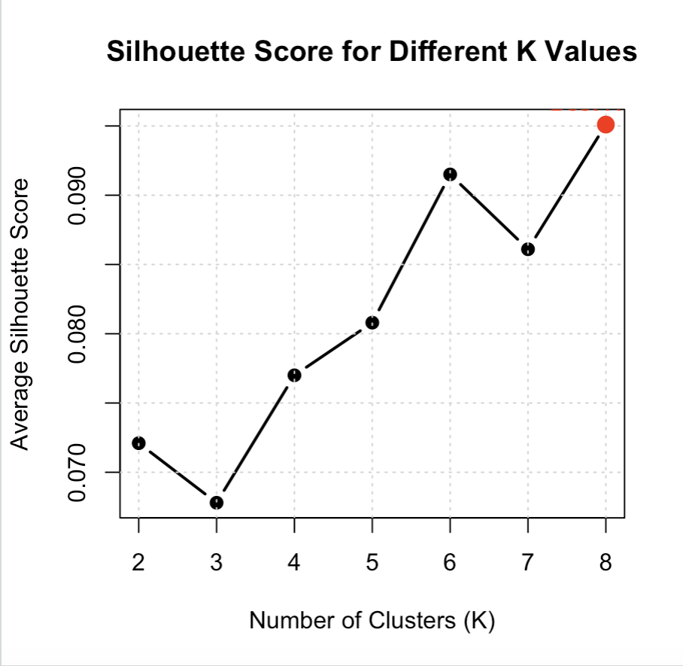
Fig. 2. Silhouette Score across different K values.

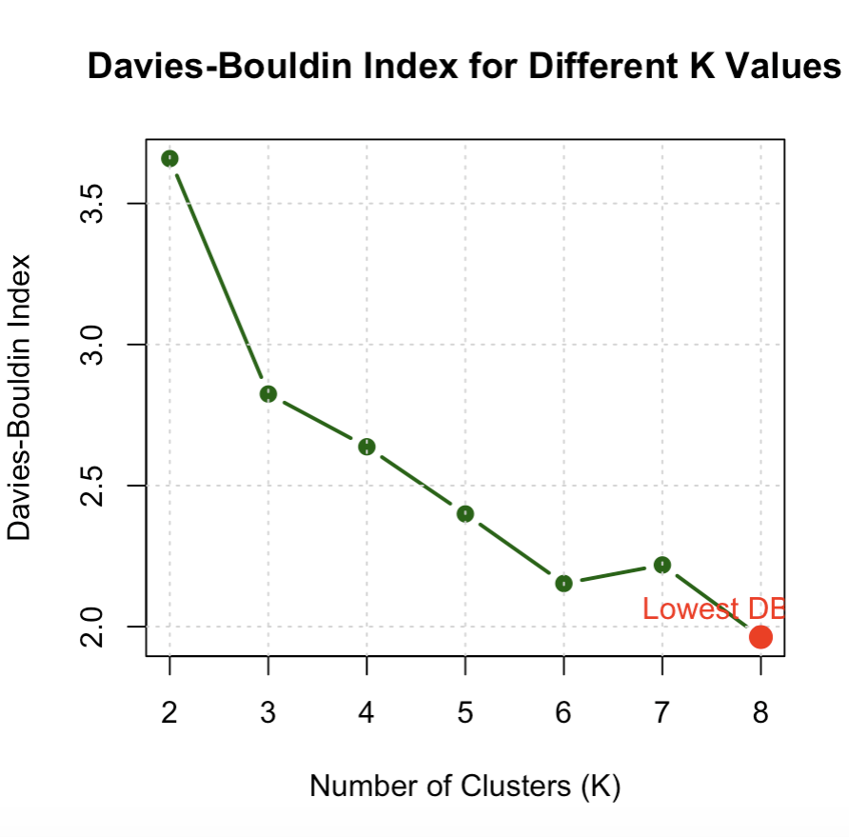

Fig. 3. Davies-Bouldin Index across different K values.
The evaluation plots show that increasing the number of clusters improved the separation to some extent. Although the silhouette values were low overall, K = 8 showed the best relative performance in this experiment.

D. Final Clustering Result
Using K = 8, the final K-Means clustering model grouped the 200 biomedical abstracts into eight clusters. The distribution of documents across the clusters is shown in Table VII.
Table VII. Final Cluster Distribution
Cluster | Number of Documents
1 | 10
2 | 13
3 | 4
4 | 5
5 | 63
6 | 9
7 | 33
8 | 63
Total | 200

The clusters were not equally distributed. Cluster 5 and Cluster 8 contained the largest number of documents, while Cluster 3 and Cluster 4 contained fewer documents. This is acceptable in unsupervised clustering because K-Means groups documents based on text similarity, not based on equal document count.
Table VIII. Disease Group Distribution across Final Clusters
Disease Group | C1 | C2 | C3 | C4 | C5 | C6 | C7 | C8
Cancer | 0 | 0 | 4 | 1 | 11 | 2 | 12 | 20
Cardiovascular | 8 | 0 | 0 | 1 | 24 | 1 | 9 | 7
Diabetes | 0 | 0 | 0 | 3 | 17 | 2 | 9 | 19
Neurological | 2 | 13 | 0 | 0 | 11 | 4 | 3 | 17

Table VIII shows that the clusters did not perfectly match the four disease labels. Instead, several clusters contained documents from multiple disease groups. This indicates that biomedical abstracts often share common clinical and scientific terminology across different diseases. Therefore, the clusters should be interpreted as biomedical themes rather than strict disease classes.

E. Final Evaluation Metrics

The final clustering model was evaluated using Silhouette Score and Davies-Bouldin Index. The final values are presented in Table IX.
Table IX. Final Clustering Evaluation Summary
Metric | Value | Better Condition
Silhouette Score | 0.0909 | Higher is better
Davies-Bouldin Index | 2.0885 | Lower is better

The final Silhouette Score was 0.0909, which indicates weak separation between clusters. This result suggests that the biomedical abstracts contain overlapping themes. Such overlap is expected because disease-related biomedical research often shares common terms such as clinical, risk, outcomes, treatment, expression, cells, and patients. Similar biomedical document clustering studies also report that vector representation and text complexity strongly influence clustering quality.
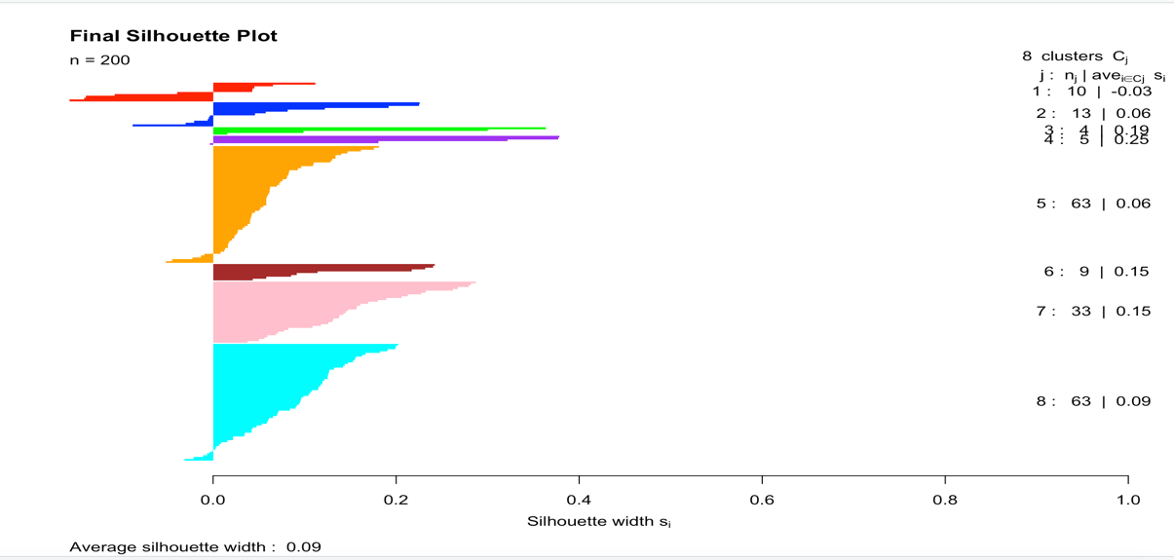
Fig. 4. Final silhouette plot for K = 8.
The silhouette plot shows that some clusters have stronger separation than others, while several documents are close to cluster boundaries. This supports the observation that the dataset contains overlapping biomedical themes.

F. Keyword-Based Cluster Interpretation
To understand the meaning of each cluster, the top TF-IDF keywords were extracted. These keywords were used to assign an approximate theme to each cluster.

Table X. Top Keywords and Interpretation of Final Clusters
Cluster | Important Keywords | Interpreted Theme
1 | artery, coronary, myocardial, heart, imaging | Cardiovascular and coronary disease-related studies
2 | brain, neural, functional, disorder, receptor | Neurological and brain-function-related studies
3 | tumor, protein, cell, pathway, genes | Cancer molecular and cellular mechanism
4 | care, people, health, diabetes, system | Healthcare, public health, and diabetes-related care
5 | outcomes, clinical, heart, safety, accuracy | Clinical outcomes and health evaluation
6 | case, chronic, report, surgical, examination | Case-based, chronic, and surgical studies
7 | risk, cancer, age, women, men, factors | Risk factor and population-level disease studies
8 | cells, expression, genes, glucose, mechanism | Cellular, gene-expression, and metabolic mechanisms

The keyword analysis helped explain the thematic meaning of the clusters. For example, Cluster 1 was mainly associated with cardiovascular terms, while Cluster 2 represented neurological themes. Cluster 3 contained cancer-related molecular terms, and Cluster 8 contained cellular and metabolic terms. This shows that the clustering process discovered meaningful biomedical themes from abstract text.
Biomedical document clustering studies often interpret clusters using keywords, representative words, or visual summaries such as word clouds to understand the topic of each group. In this study, top TF-IDF terms were used for cluster interpretation because they directly represent the most important words in each cluster.

G. UMAP Visualization
UMAP was used to visualize the final clusters in a two-dimensional space. The visualization is shown in Fig. 5.
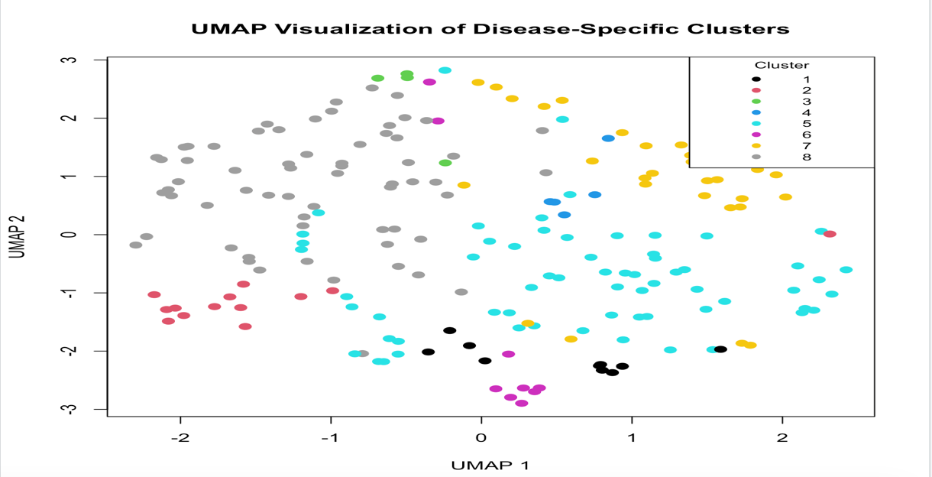

Fig. 5. UMAP visualization of disease-specific biomedical document clusters.
The UMAP plot shows the distribution of biomedical abstracts across the final clusters. Some clusters are visually close to each other, indicating that their documents share similar vocabulary and biomedical concepts. This result is consistent with the low Silhouette Score, which also suggests overlap among clusters.
The visualization supports the main finding of this study: disease-related biomedical abstracts do not always form completely separate groups. Instead, they often overlap through shared clinical, molecular, and population-level research themes.

H. Overall Discussion
The results show that unsupervised clustering can be used to organize biomedical abstracts into meaningful thematic groups. Although the selected dataset was balanced across four disease groups, the final clusters were not purely disease-specific. This is because many biomedical studies discuss shared concepts such as risk factors, clinical outcomes, gene expression, treatment response, and healthcare systems. The highest Silhouette Score and lowest Davies-Bouldin Index were obtained at K = 8. Therefore, the final clustering model produced eight thematic groups rather than four direct disease categories. This finding is important because it shows that biomedical knowledge is often connected across diseases. For example, cancer and diabetes abstracts may share molecular or metabolic terms, while cardiovascular and neurological studies may share risk-related or clinical terms. The result also suggests that disease-specific knowledge mapping should not only focus on disease labels. Instead, it should consider hidden themes and relationships present in biomedical text. Therefore, the proposed approach can support structured exploration of biomedical literature by grouping similar abstracts and identifying important disease-related topics.

Code:
library(tm)
library(cluster)
library(uwot)
library(clusterSim)

raw_data <- read.csv("biomedical_research_abstracts_2024_2026.csv", stringsAsFactors = FALSE)
dim(raw_data )
head(raw_data )

selected_data <- raw_data[, c("pmid", "title", "abstract", "abstract_words", "journal", "pub_year", "country", "keywords", "major_topic")]

selected_data <- selected_data[!is.na(selected_data$abstract), ]
selected_data <- selected_data[selected_data$abstract != "", ]
dim(selected_data)
sum(is.na(selected_data$abstract))

selected_data$title <- trimws(selected_data$title)
selected_data$abstract <- trimws(selected_data$abstract)
selected_data$keywords <- ifelse(is.na(selected_data$keywords), "", selected_data$keywords)
selected_data$major_topic <- ifelse(is.na(selected_data$major_topic), "", selected_data$major_topic)
head(selected_data[, c("title", "keywords", "major_topic")])

selected_data <- selected_data[!duplicated(selected_data$pmid), ]
selected_data <- selected_data[!duplicated(selected_data$title), ]

selected_data <- selected_data[selected_data$abstract_words >= 80 & selected_data$abstract_words <= 350, ]

all_text <- paste(selected_data$title, selected_data$abstract, selected_data$keywords, selected_data$major_topic)
all_text <- tolower(all_text)

diabetes_pattern <- "diabetes|insulin|glucose|glycemic"
cancer_pattern <- "cancer|tumor|tumour|oncology|carcinoma|chemotherapy"
cardio_pattern <- "cardiovascular|heart disease|hypertension|myocardial|coronary"
neuro_pattern <- "neurological|brain|alzheimer|parkinson|dementia|stroke"

diabetes_data <- selected_data[
grepl(diabetes_pattern, all_text) &
!grepl(cancer_pattern, all_text) &
!grepl(cardio_pattern, all_text) &
!grepl(neuro_pattern, all_text),
]

cancer_data <- selected_data[
grepl(cancer_pattern, all_text) &
!grepl(diabetes_pattern, all_text) &
!grepl(cardio_pattern, all_text) &
!grepl(neuro_pattern, all_text),
]

cardio_data <- selected_data[
grepl(cardio_pattern, all_text) &
!grepl(diabetes_pattern, all_text) &
!grepl(cancer_pattern, all_text) &
!grepl(neuro_pattern, all_text),
]

neuro_data <- selected_data[
grepl(neuro_pattern, all_text) &
!grepl(diabetes_pattern, all_text) &
!grepl(cancer_pattern, all_text) &
!grepl(cardio_pattern, all_text),
]

diabetes_data$disease_group <- "Diabetes"
cancer_data$disease_group <- "Cancer"
cardio_data$disease_group <- "Cardiovascular"
neuro_data$disease_group <- "Neurological"

nrow(diabetes_data)
nrow(cancer_data)
nrow(cardio_data)
nrow(neuro_data)

set.seed(42)

diabetes_sample <- diabetes_data[sample(1:nrow(diabetes_data), 50), ]
cancer_sample <- cancer_data[sample(1:nrow(cancer_data), 50), ]
cardio_sample <- cardio_data[sample(1:nrow(cardio_data), 50), ]
neuro_sample <- neuro_data[sample(1:nrow(neuro_data), 50), ]

project_data <- rbind(diabetes_sample, cancer_sample, cardio_sample, neuro_sample)

project_data <- project_data[sample(1:nrow(project_data)), ]

clean_text <- function(x) {
x <- tolower(x)
x <- gsub("[^a-z ]", " ", x)
x <- gsub("\\s+", " ", x)
x <- trimws(x)
return(x)
}

project_data$clean_abstract <- clean_text(project_data$abstract)

table(project_data$disease_group)
dim(project_data)
head(project_data[, c("disease_group", "clean_abstract")])
write.csv(project_data, "ids_final_dataset_group_10.csv", row.names = FALSE)

data <- read.csv("ids_final_dataset_group_10.csv", stringsAsFactors = FALSE)

dim(data)
names(data)
table(data$disease_group)
head(data[, c("title", "disease_group", "clean_abstract")])

data$text <- data$clean_abstract
data$text <- ifelse(is.na(data$text), "", data$text)

corpus <- VCorpus(VectorSource(data$text))

corpus <- tm_map(corpus, content_transformer(tolower))
corpus <- tm_map(corpus, removePunctuation)
corpus <- tm_map(corpus, removeNumbers)
corpus <- tm_map(corpus, removeWords, stopwords("english"))
corpus <- tm_map(corpus, removeWords, c("study","patient","patients","result","results","method","methods","conclusion","background","objective"))
corpus <- tm_map(corpus, stripWhitespace)

as.character(corpus[[1]])

dtm <- DocumentTermMatrix(corpus)

dtm <- removeSparseTerms(dtm, 0.95)

tfidf <- weightTfIdf(dtm)

tfidf_matrix <- as.matrix(tfidf)

dim(tfidf_matrix)
tfidf_matrix[1:5, 1:5]

set.seed(42)
pca_result <- prcomp(tfidf_matrix, center = TRUE, scale. = FALSE)
pca_data <- pca_result$x[, 1:20]
dim(pca_data)

set.seed(42)

k_values <- 2:8
sil_scores <- numeric(length(k_values))
db_scores <- numeric(length(k_values))

for (i in seq_along(k_values)) {
km <- kmeans(pca_data, centers = k_values[i], nstart = 50)
sil <- silhouette(km$cluster, dist(pca_data))
db <- index.DB(x = pca_data, cl = km$cluster, centrotypes = "centroids")
sil_scores[i] <- mean(sil[, 3])
db_scores[i] <- db$DB
}

evaluation_by_k <- data.frame(
K = k_values,
Silhouette_Score = round(sil_scores, 4),
Davies_Bouldin_Index = round(db_scores, 4)
)

evaluation_by_k

best_k <- evaluation_by_k$K[which.max(evaluation_by_k$Silhouette_Score)]

best_k

plot(
evaluation_by_k$K,
evaluation_by_k$Silhouette_Score,
type = "b",
pch = 19,
lwd = 2,
xlab = "Number of Clusters (K)",
ylab = "Average Silhouette Score",
main = "Silhouette Score for Different K Values"
)
grid()

points(
best_k,
max(evaluation_by_k$Silhouette_Score),
pch = 19,
cex = 1.5,
col="red"
)

text(
best_k,
max(evaluation_by_k$Silhouette_Score),
labels = paste("Best K =", best_k),
pos = 3,
col="red"
)

best_k_db <- evaluation_by_k$K[which.min(evaluation_by_k$Davies_Bouldin_Index)]
plot(
evaluation_by_k$K,
evaluation_by_k$Davies_Bouldin_Index,
type = "b",
pch = 19,
lwd = 2,
col="darkgreen",
xlab = "Number of Clusters (K)",
ylab = "Davies-Bouldin Index",
main = "Davies-Bouldin Index for Different K Values"
)
grid()
points(
best_k_db,
min(evaluation_by_k$Davies_Bouldin_Index),
pch = 19,
cex = 1.6,
col = "red"
)

text(
best_k_db,
min(evaluation_by_k$Davies_Bouldin_Index),
labels = paste("Lowest DBI K =", best_k_db),
pos = 3,
col = "red"
)

best_k <- evaluation_by_k$K[which.max(evaluation_by_k$Silhouette_Score)]
best_k

set.seed(42)

final_model <- kmeans(pca_data, centers = best_k, nstart = 50)

data$final_cluster <- as.factor(final_model$cluster)

table(data$final_cluster)

table(data$disease_group, data$final_cluster)

final_silhouette <- silhouette(final_model$cluster, dist(pca_data))

final_mean_silhouette <- mean(final_silhouette[, 3])

final_db <- index.DB(
x = pca_data,
cl = final_model$cluster,
centrotypes = "centroids"
)

final_mean_silhouette

final_db$DB

evaluation_table <- data.frame(
Metric = c("Silhouette Score", "Davies-Bouldin Index"),
Value = c(round(final_mean_silhouette, 4), round(final_db$DB, 4)),
Interpretation = c(
"Higher value is better",
"Lower value is better"
),
stringsAsFactors = FALSE
)

evaluation_table

plot(
final_silhouette,
main = "Final Silhouette Plot",
col = c("red", "blue", "green", "purple", "orange", "brown", "pink", "cyan"),
border = NA,
cex.names = 0.75,
do.n.k = TRUE,
do.clus.stat = TRUE
)

top_terms <- function(cluster_number, matrix_data, dataset, cluster_column, top_n = 10) {
rows <- dataset[[cluster_column]] == cluster_number
cluster_words <- colMeans(matrix_data[rows, , drop = FALSE])
cluster_words <- sort(cluster_words, decreasing = TRUE)
names(cluster_words)[1:top_n]
}

cluster_keywords <- data.frame(
Cluster_1 = top_terms("1", tfidf_matrix, data, "final_cluster"),
Cluster_2 = top_terms("2", tfidf_matrix, data, "final_cluster"),
Cluster_3 = top_terms("3", tfidf_matrix, data, "final_cluster"),
Cluster_4 = top_terms("4", tfidf_matrix, data, "final_cluster"),
Cluster_5 = top_terms("5", tfidf_matrix, data, "final_cluster"),
Cluster_6 = top_terms("6", tfidf_matrix, data, "final_cluster"),
Cluster_7 = top_terms("7", tfidf_matrix, data, "final_cluster"),
Cluster_8 = top_terms("8", tfidf_matrix, data, "final_cluster"),
stringsAsFactors = FALSE
)

cluster_keywords

cluster_summary <- aggregate(
pmid ~ final_cluster + disease_group,
data = data,
FUN = length
)

names(cluster_summary) <- c("Cluster", "Disease_Group", "Document_Count")

cluster_summary

set.seed(42)

umap_result <- umap(tfidf_matrix, n_neighbors = 15, min_dist = 0.1, metric = "cosine")

umap_data <- data.frame(
UMAP1 = umap_result[, 1],
UMAP2 = umap_result[, 2],
Cluster = data$final_cluster,
Disease = data$disease_group
)

plot(
umap_data$UMAP1,
umap_data$UMAP2,
col = as.numeric(umap_data$Cluster),
pch = 19,
cex = 1.2,
xlab = "UMAP 1",
ylab = "UMAP 2",
main = "UMAP Visualization of Disease-Specific Clusters"
)

legend(
"topright",
legend = levels(umap_data$Cluster),
col = 1:length(levels(umap_data$Cluster)),
pch = 19,
title = "Cluster",
cex = 0.8
)

